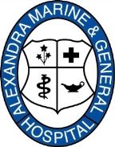 | Alexandra Marine and General Hospital  New Employee Information Form

Name:
Address:
911 number and road (if applicable):
Town:
Postal Code:
Telephone:
Social Insurance Number:
Date of Birth:
Email address (optional):
Emergency Contact:
Name:
Address:
Town:
Telephone:
Are you a current member of the Hospital of Ontario Pension Plan (HOOPP)? Please circle one.
Yes | No
If yes, please sign:
Signature:
Date:

Please return to Peggy Byrne Carter, Human Resources
patricia.byrnecarter@amgh.ca
519-524-8689, Ext. 5720
Fax: 519-524-8537

